# ASSIGNMENT 3 – CO-INTEGRATION

The superior test for cointegration is Johansen’s test (1995). The weakness of the test is that it relies on asymptotic properties and sensitive to specification errors in limited samples.

**Command - vecrank brazil chile colombia costarica, trend(constant) max**

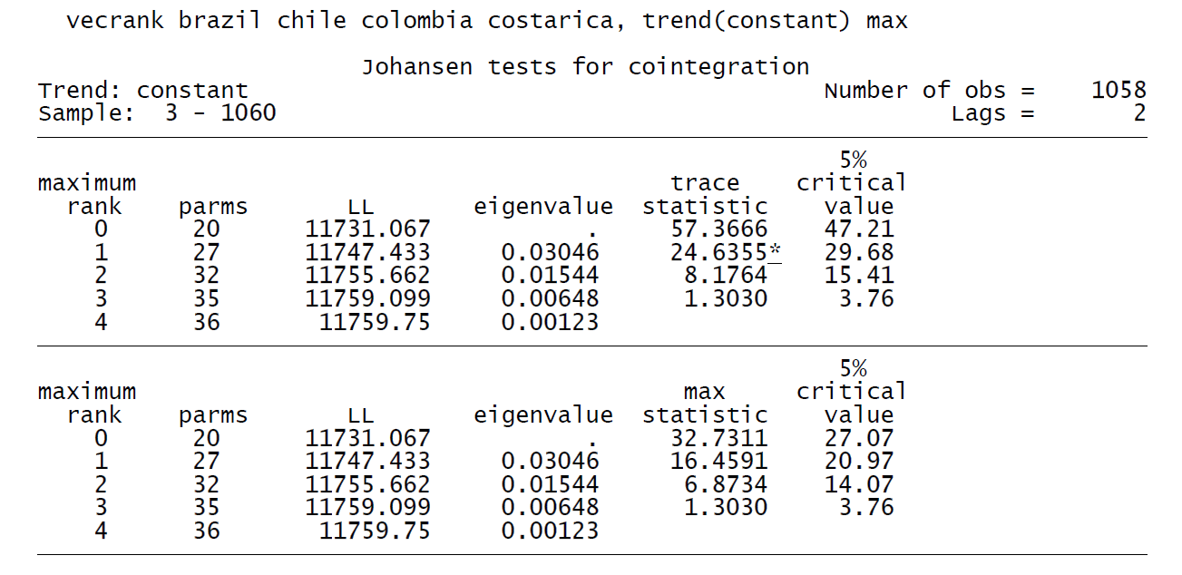

The maximum rank column represents NULL hypothesis

Rank0: H0 => No co-integrating vector

Rank:1 H0 => 1 CO-INTEGRATING VECTOR

Ranl:2 H0=> 2 CO-INTEGRATING VECTORS

**Trace statistic (lambda – trace)**

Necessary but not sufficient condition for determining the number of co-integrating vectors.If lambda-trace is greater than 5% critical value probability, then we will reject NULL hypothesis (H0). It has found that the trace test is the better test, since it appears to be more robust to skewness and excess kurtosis.

**Max statistic**

Necessary and sufficient condition for determining the number of co-integrating vectors

Looking at the max statistic, the lambda-trace for rank 0 is greater than the 5% critical value, meaning that we have at the maximum 1 co-integrating vector. From the above performed Johansen Test, We can see that the trace test and the max-eigenvalue co-integration rank tests are different because they test different hypotheses.

**Step 1: Lag Selection**

**Command - varsoc brazil chile colombia costarica, maxlag(8)**

The varsoc reports the final prediction error (FPE), Akaike’s information criterion (AIC), Schwarz’s Bayesian information criterion (SBIC), and the Hannan and Quinn information criterion (HQIC) lagorder selection statistics for a series of vector autoregressions of order 1, . . . , maxlag(). A sequence of likelihood-ratio test statistics for all the full VARs of order less than or equal to the highest lag order is also reported. In the postestimation version, the maximum lag and estimation options are based on the model just fit or the model specified in estimates(estname). The preestimation version of varsoc can also be used to select the lag order for a vector errorcorrection model (VECM).

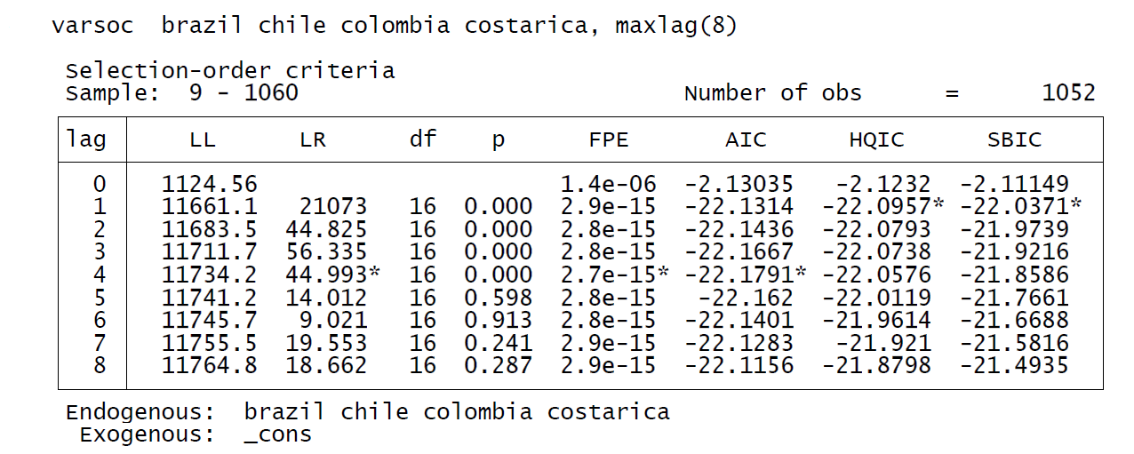

We have calculated the observations upto lab length of 8.

From the above table we can see that AIC and FPE suggest lag length of 4, whereas HQIC and SBIC suggests lag length of 1. So mostly lag 4 can be recommended.

**Step2: Test of Stationarity**

**Command – corrgram brazil**

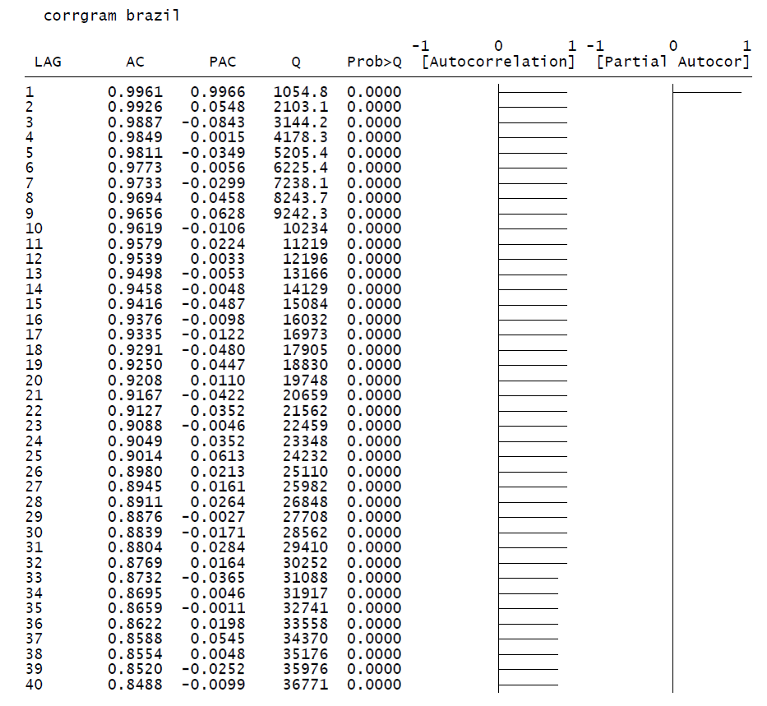

It can be observed from the above figure that our series is non-stationary. So, we take the first difference and make it stationary

**Command – d.brazil**

**LAG AC PAC Q Prob>Q [Autocorrelation] [Partial Autocor]**

**-------------------------------------------------------------------------------**

**1 -0.0540 -0.0540 3.0938 0.0786 | |**

**2 0.0879 0.0853 11.312 0.0035 | |**

**3 -0.0098 -0.0009 11.414 0.0097 | |**

**4 0.0432 0.0355 13.399 0.0095 | |**

**5 -0.0101 -0.0052 13.508 0.0191 | |**

**6 0.0375 0.0304 15.005 0.0202 | |**

**7 -0.0497 -0.0454 17.639 0.0137 | |**

**8 -0.0494 -0.0622 20.245 0.0094 | |**

**9 0.0079 0.0114 20.312 0.0161 | |**

**10 -0.0284 -0.0216 21.175 0.0199 | |**

**11 -0.0019 -0.0024 21.179 0.0316 | |**

**12 -0.0002 0.0063 21.179 0.0478 | |**

**13 0.0033 0.0058 21.191 0.0692 | |**

**14 0.0446 0.0496 23.328 0.0551 | |**

**15 0.0126 0.0104 23.498 0.0741 | |**

**16 0.0189 0.0128 23.885 0.0920 | |**

**17 0.0489 0.0485 26.466 0.0664 | |**

**18 -0.0381 -0.0444 28.03 0.0616 | |**

**19 0.0018 -0.0105 28.033 0.0828 | |**

**20 0.0393 0.0427 29.702 0.0748 | |**

**21 -0.0386 -0.0350 31.311 0.0686 | |**

**22 0.0064 0.0050 31.355 0.0891 | |**

**23 -0.0389 -0.0348 32.998 0.0811 | |**

**24 -0.0620 -0.0609 37.175 0.0420 | |**

**25 -0.0254 -0.0206 37.876 0.0476 | |**

**26 -0.0131 -0.0153 38.063 0.0598 | |**

After taking the first difference the series become stationary as the spikes of ACF and PACF lies within the 95% confidence interval.

Change the value of lag length to 4 and check the VECM

***Command - vec brazil chile colombia costarica, trend(constant) lags(5) max***

Vector error-correction model

Sample: 5 - 1060 No. of obs = 1056

AIC = -22.18306

Log likelihood = 11771.66 HQIC = -22.07797

Det(Sigma_ml) = 2.44e-15 SBIC = -21.90581

Equation Parms RMSE R-sq chi2 P>chi2

----------------------------------------------------------------

D_brazil 14 .018619 0.0310 33.30687 0.0026

D_chile 14 .02203 0.0495 54.22689 0.0000

D_colombia 14 .011011 0.0553 60.96032 0.0000

D_costarica 14 .012148 0.0504 55.26114 0.0000

----------------------------------------------------------------

------------------------------------------------------------------------------

| Coef. Std. Err. z P>|z| [95% Conf. Interval]

-------------+----------------------------------------------------------------

D_brazil |

**_ce1** |

L1. | -.0009706 .0008824 -1.10 0.271 -.0027001 .0007588

|

brazil |

LD. | -.0561471 .03265 -1.72 0.085 -.12014 .0078457

L2D. | .0555919 .0325528 1.71 0.088 -.0082103 .1193941

L3D. | .002182 .0325218 0.07 0.947 -.0615597 .0659236

|

chile |

LD. | -.012659 .0272229 -0.47 0.642 -.0660148 .0406969

L2D. | -.0001365 .0270572 -0.01 0.996 -.0531676 .0528946

L3D. | .004203 .0266566 0.16 0.875 -.048043 .0564491

|

colombia |

LD. | .0624517 .0545293 1.15 0.252 -.0444238 .1693272

L2D. | .1853984 .0544791 3.40 0.001 .0786214 .2921754

L3D. | -.0774434 .0551811 -1.40 0.160 -.1855965 .0307097

|

costarica |

LD. | .0438751 .0469749 0.93 0.350 -.0481941 .1359442

L2D. | .0023852 .0475272 0.05 0.960 -.0907663 .0955367

L3D. | .0432462 .0475558 0.91 0.363 -.0499616 .1364539

|

_cons | 8.92e-07 .0007759 0.00 0.999 -.0015199 .0015217

-------------+----------------------------------------------------------------

D_chile |

_ce1 |

L1. | .0004379 .0010441 0.42 0.675 -.0016085 .0024843

|

brazil |

LD. | .011859 .038633 0.31 0.759 -.0638603 .0875782

L2D. | .0900446 .0385179 2.34 0.019 .014551 .1655383

L3D. | .0057134 .0384813 0.15 0.882 -.0697086 .0811354

|

chile |

LD. | .0279255 .0322113 0.87 0.386 -.0352075 .0910586

L2D. | -.0597063 .0320153 -1.86 0.062 -.1224551 .0030425

L3D. | .0277401 .0315413 0.88 0.379 -.0340798 .08956

|

colombia |

LD. | -.0755481 .0645216 -1.17 0.242 -.202008 .0509119

L2D. | -.0629637 .0644621 -0.98 0.329 -.1893071 .0633796

L3D. | -.0291004 .0652928 -0.45 0.656 -.157072 .0988711

|

costarica |

LD. | -.2940921 .0555828 -5.29 0.000 -.4030325 -.1851517

L2D. | .1233788 .0562363 2.19 0.028 .0131577 .2335999

L3D. | -.1882676 .0562702 -3.35 0.001 -.2985552 -.07798

|

_cons | .0006182 .0009181 0.67 0.501 -.0011813 .0024176

-------------+----------------------------------------------------------------

D_colombia |

_ce1 |

L1. | -.0015965 .0005218 -3.06 0.002 -.0026193 -.0005737

|

brazil |

LD. | -.0010966 .0193087 -0.06 0.955 -.038941 .0367479

L2D. | .0400285 .0192512 2.08 0.038 .0022968 .0777602

L3D. | -.0276531 .0192329 -1.44 0.150 -.0653489 .0100427

|

chile |

LD. | -.0098477 .0160992 -0.61 0.541 -.0414015 .0217061

L2D. | .0007388 .0160012 0.05 0.963 -.0306229 .0321006

L3D. | .0111722 .0157643 0.71 0.479 -.0197253 .0420698

|

colombia |

LD. | .011485 .0322478 0.36 0.722 -.0517195 .0746896

L2D. | .1030112 .0322181 3.20 0.001 .0398649 .1661574

L3D. | .0638774 .0326333 1.96 0.050 -.0000827 .1278375

|

costarica |

LD. | .0065427 .0277803 0.24 0.814 -.0479056 .060991

L2D. | .0169275 .0281068 0.60 0.547 -.0381609 .0720159

L3D. | .0034345 .0281238 0.12 0.903 -.0516871 .0585562

|

_cons | .0001057 .0004589 0.23 0.818 -.0007937 .0010051

-------------+----------------------------------------------------------------

D_costarica |

_ce1 |

L1. | -.0019109 .0005757 -3.32 0.001 -.0030393 -.0007825

|

brazil |

LD. | -.0286463 .0213027 -1.34 0.179 -.0703989 .0131062

L2D. | .0124092 .0212392 0.58 0.559 -.029219 .0540373

L3D. | .0156993 .0212191 0.74 0.459 -.0258893 .0572879

|

chile |

LD. | -.0067662 .0177617 -0.38 0.703 -.0415786 .0280461

L2D. | .0524571 .0176536 2.97 0.003 .0178566 .0870575

L3D. | .0060787 .0173923 0.35 0.727 -.0280095 .040167

|

colombia |

LD. | -.0207499 .035578 -0.58 0.560 -.0904815 .0489817

L2D. | -.0901927 .0355452 -2.54 0.011 -.15986 -.0205255

L3D. | .0159445 .0360033 0.44 0.658 -.0546207 .0865096

|

costarica |

LD. | -.0444413 .0306491 -1.45 0.147 -.1045124 .0156298

L2D. | -.0072252 .0310094 -0.23 0.816 -.0680025 .0535521

L3D. | .1272339 .0310281 4.10 0.000 .06642 .1880479

|

_cons | .0000529 .0005063 0.10 0.917 -.0009393 .0010451

------------------------------------------------------------------------------

The error correction term “**_cel”** should be negative and significant. If it’s not significant then means the market is weakly significant. Bigger the error correction term better the co-integration. If it’s positive then aggravation will be larger than correction. The absolute value of error correction should be higher meaning it will correct the market faster.

**Test to see if there is causality between our variables**

For the causality the Null hypothesis is --- There is no causality.

***Command - test (LD.chile L2D.chile L3D.chile L4D.chile)***

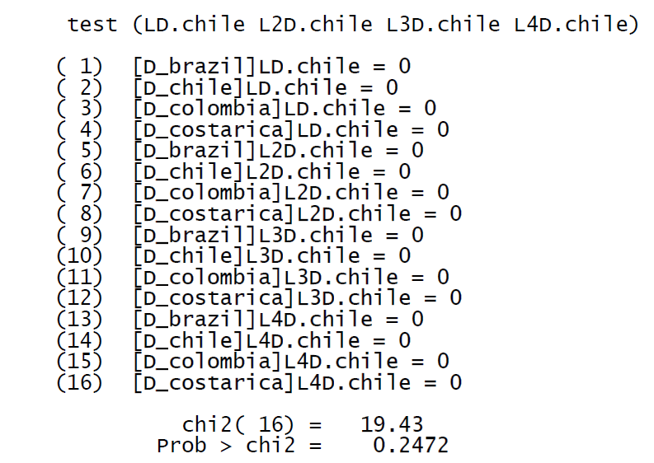

The null hypothesis is not rejected, meaning there is no causality between Chile to brazil.

Similarly testing for Colombia, we get the following output

***COMMAND - test (LD.colombia L2D.colombia L3D.colombia L4D.colombia)***

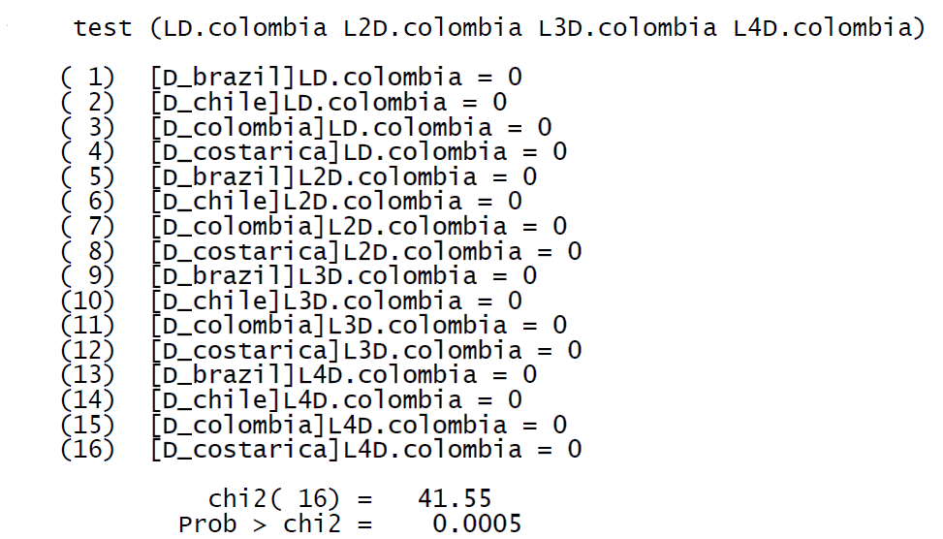

Looking at the above we output, we see that causality exists between Colombia and brazil

**Checking for autocorrelation**

***Command - veclmar, mlag(8)***

veclmar implements a Lagrange multiplier (LM) test for autocorrelation in the residuals of vector error-correction models (VECMs).

mlag(#) specifies the maximum order of autocorrelation to be tested. The integer specified in mlag() must be greater than 0; the default is 2.

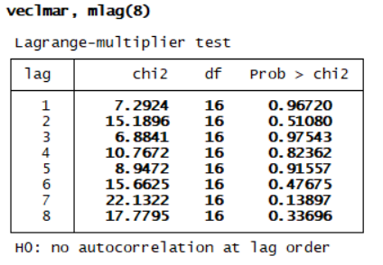

At the 5% level, we cannot reject the null hypothesis that there is no autocorrelation in the residuals for any of the orders tested. Thus this test finds no evidence of model misspecification.

**MAKING THE ERROR TERMS NORMALLY DISRIBUTED**

***Command - vecnorm, jbera***

vecnorm computes and reports a series of statistics against the null hypothesis that the disturbances in a VECM are normally distributed.

* jbera requests that the Jarque–Bera statistic and any other explicitly requested statistic be reported. By default, the Jarque–Bera, skewness, and kurtosis statistics are reported.
* skewness requests that the skewness statistic and any other explicitly requested statistic be reported. By default, the Jarque–Bera, skewness, and kurtosis statistics are reported.
* kurtosis requests that the kurtosis statistic and any other explicitly requested statistic be reported. By default, the Jarque–Bera, skewness, and kurtosis statistics are reported

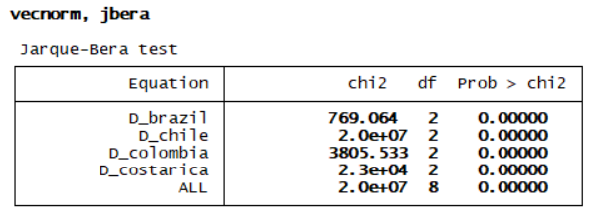

The Jarque–Bera results present test statistics for each equation and for all equations jointly against the null hypothesis of normality. For the individual equations, the null hypothesis is that the disturbance term in that equation has a univariate normal distribution. For all equations jointly, the null hypothesis is that the K disturbances come from a K-dimensional normal distribution. In this example, the single-equation and overall Jarque–Bera statistics rejects the null of normality.